PHP Final Examinate
Laravel 5.5 CRUD data.
Using :
- PHP ^7.0
- Laravel 5.5
- Bootstrap ^4
Required :
- Using Composer to install Laravel via command line, naming folder of Laravel : your-name-aptech-php-yourclass-laravel (example : namnh-aptech-yourclass-laravel).
- Creating users table on database aptech_php_yourclass_laravel using migration feature of Laravel, there are some of column's name and type of data :
users
id | Integer, Primary Key, Auto Increments
name | Varchar (100)
email | Varchar (100), Unique
password | Varchar (100)
created_at | Timestamp
updated_at | Timestamp

- Creating User Model to manipulate users table.
- Adding data into users table ( using Seeder feature + Faker library, at least 5 records).
- Creating UserController and 7 functions for CRUD data.
- Creating 7 routes and pointing to 7 functions of UserController, using get, post, put, delete wisely.

- Using bootstrap ^4 to create View Blade of Laravel to display data, at least 4 pages :
- Index (Displaying one by one of user’s information: id, name, email and 3 actions show, edit, delete, …).
- Show (Display particular user: id, name, email, password, created date, updated date, …)
- Edit (Editing user’s data form).
- Create (Creating user’s data form).
- Testing everything is working perfectly.
INDEX PAGE
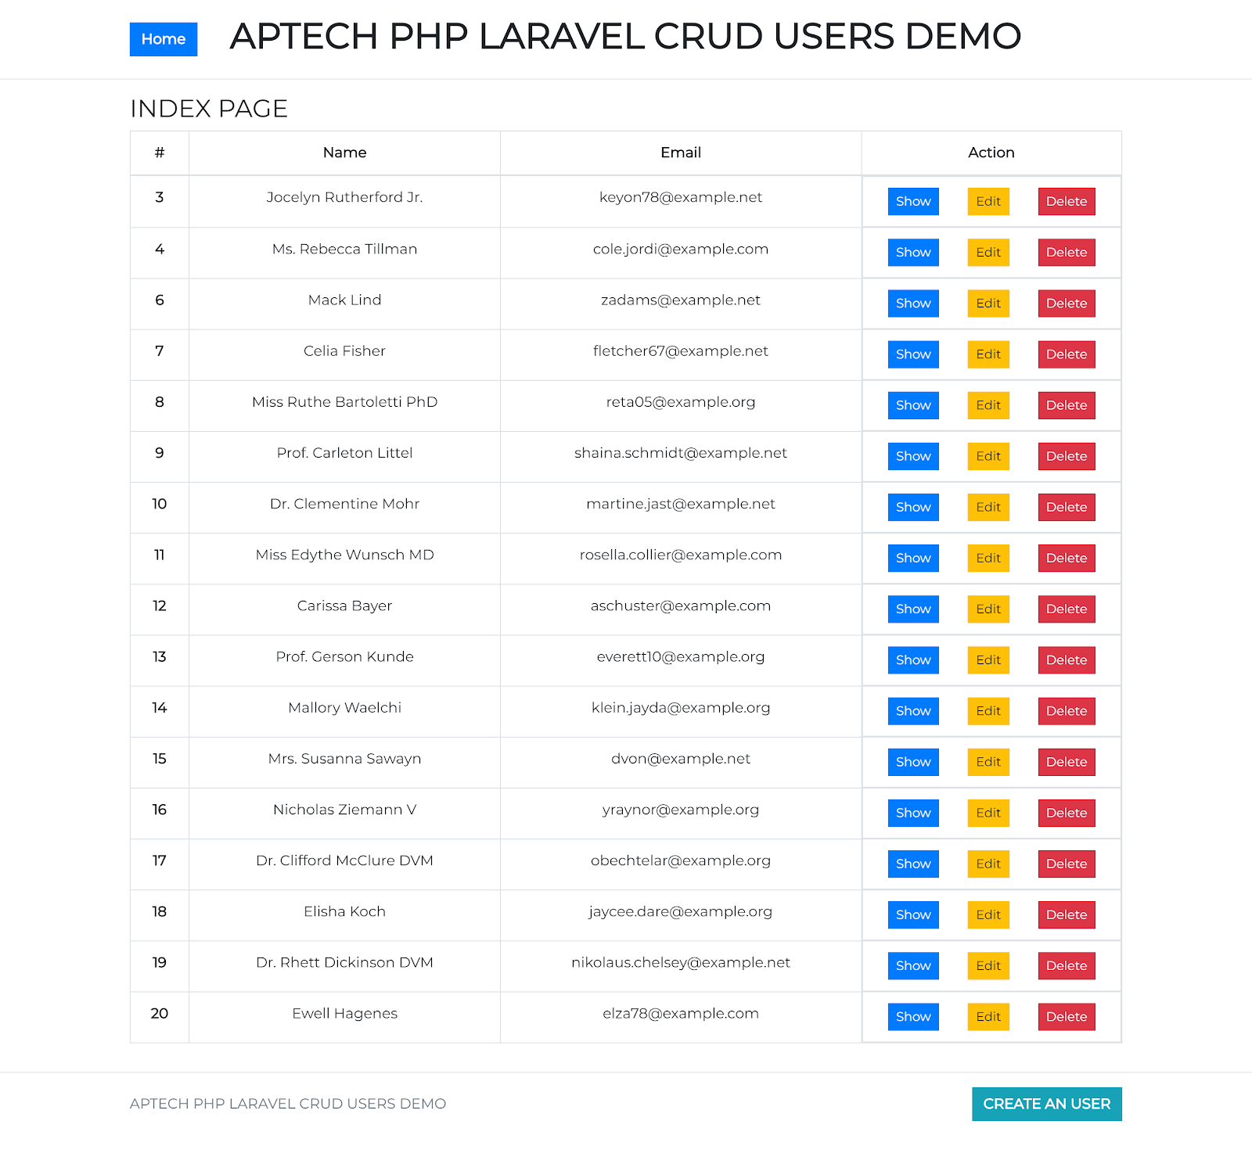
SHOW PAGE
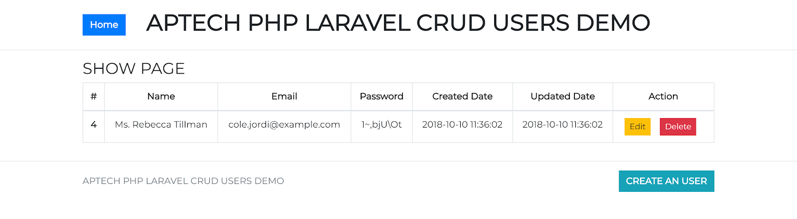
CREATE PAGE
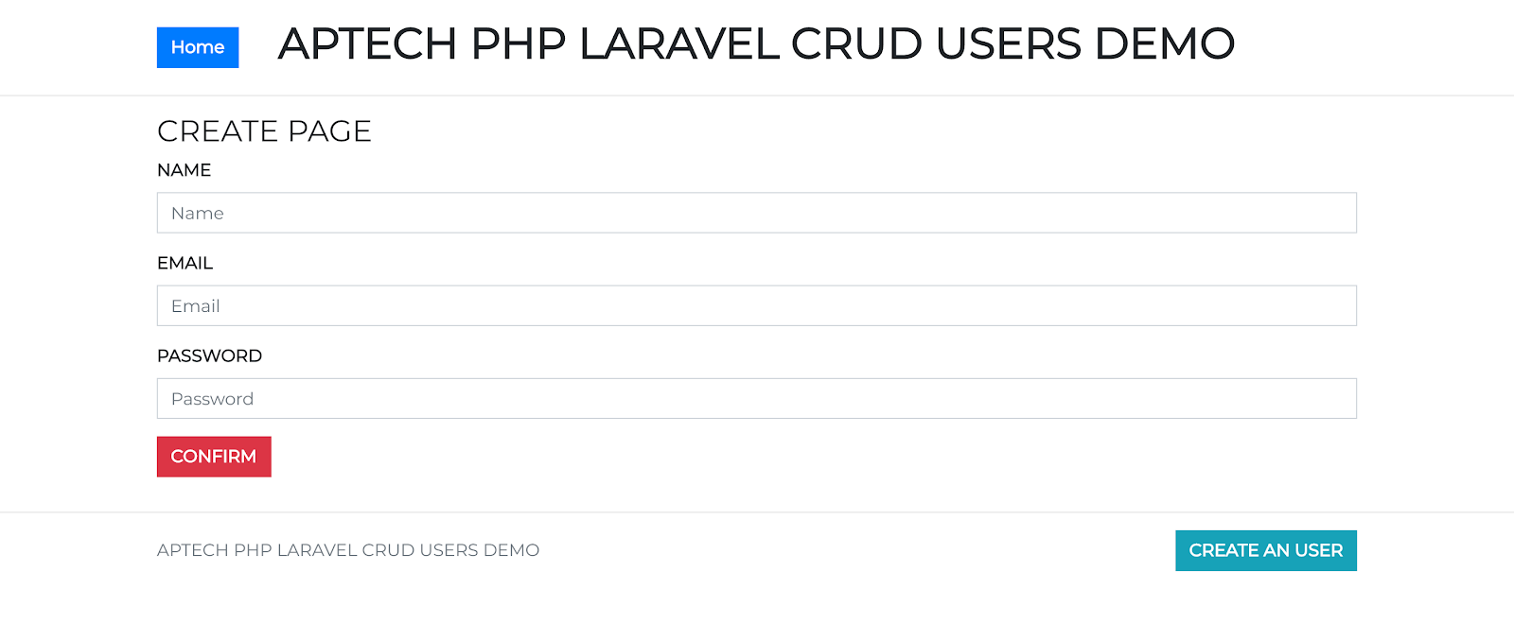
EDIT PAGE
